Project Design Phase-II

Data Flow Diagram & User Stories

# Data Flow Diagrams:

A Data Flow Diagram (DFD) is a traditional visual representation of the information flows within a system. A neat and clear DFD can depict the right amount of the system requirement graphically. It shows how data enters and leaves the system, what changes the information, and where data is stored.

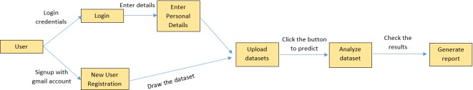

# User Stories

Use the below template to list all the user stories for the product:

|  |  |  |  |  |  |  |
| --- | --- | --- | --- | --- | --- | --- |
| **User Type** | **Functional Requirement**  **(Epic)** | **User Story**  **Number** | **User Story / Task** | **Acceptance criteria** | **Priority** | **Release** |
| Customer (user) | Registration | USN-1 | As a user, I can register for the application by entering my email, password, and  confirming my password. | I can access my  account / dashboard | High | Sprint-1 |
|  |  | USN-2 | As a user, I will receive confirmation email once I have registered for the  application | I can receive  confirmation email & click confirm | High | Sprint-1 |
|  |  | USN-3 | As a user, I can register for the application through Gmail | I can register through gmail | Medium | Sprint-1 |
|  | Login | USN-4 | As a user, I can log into the application by entering email & password | I can login and verify my account | High | Sprint-1 |
|  | Personal Details | USN-5 | As a user, I can complete my profile. | I can fill my details in the profile section | Low | Sprint-2 |
|  |  | USN-6 | As a User, I have to draw datasets | I can draw and make it available for uploading | Medium | Sprint-3 |
|  | Upload the Datasets | USN-7 | As a User, I have to upload the datasets for prediction. | I can upload the datasets drawn | High | Sprint-3 |
|  | Analyze the Dataset | USN-8 | As a User, I can analyze the result of the dataset uploaded | I can visualize the result of prediction | High | Sprint-4 |
|  | Generate Report | USN-9 | As a User, I can collect my reports | I can get my reports for further process | Low | Sprint-4 |